Final report for the ÅFORSK project: Modelling the transition of the electricity system towards zero carbon emissions (proj. no. 21-90)

Christian Azar
Division of physical resource theory
Department of Space, Earth and Environment
Chalmers
412 96 Göteborg
October 23, 2023

In June 2021, we were granted financial support from ÅFORSK for our research on the energy system on its way towards zero carbon emissions. In this report, we want to summarize the main results of our work.
In the project, two professors (Christian Azar and Kristian Lindgren) as well as associate professor Daniel Johansson and PhD Student Jinxi Yang have been involved from Chalmers. The current work has led to her PhD thesis – which will be presented in November 2023. In addition, we have collaborated with researchers from other universities, primarily Professor Sabine Fuss at the Humboldt University in Berlin.
A summary of the main output:
- We have published two scientific papers on investments in electricity markets (one focusing on the hurdle rate, carbon taxes and hetereogenous investors, and the other on risk and uncertainty);
- We have published one paper on covid recovery spending and climate change;
- We have submitted an additional paper on investments in the electricity sector (focusing on adaptive behavior of the investors);
- A PhD thesis: Jinxi Yang’s PhD thesis called “Exploring the Transition to a Low-Carbon Electricity System using Agent-Based Modelling”.
- Results from our project has been presented at various international scientific conferences;
- We have been active as experts in several government agencies/committees spreading knowledge from our work;
- We have written seven articles in the public press about our results.
Our work has centered on developing a model for the electricity system, where individual agents (companies) make investments in power plants. The key aim has been to improve modelling techniques of the electricity system, carry out modeled-based analysis how companies compete with one another, how risk, uncertainty and financial constraint affect the willingness to invest.
Overall, we believe that this scientific work may help to achieve a better understanding of how policy instruments and risk management strategies may help to reduce carbon emissions from the electricity system.
Hence, our work is strongly related to two of the central questions in the current debate about how to solve the climate problem, i.e., a) what is the impact of risk and uncertainty on green investments and b) which role may the financial markets and government policies play in the ensuring that capital is directed towards low carbon energy technologies.

A more detailed description of the papers published and submitted within this project:

- Paper 1: “Modelling the Transition towards a Carbon-Neutral Electricity System—Investment Decisions and Heterogeneity” published in Energies.
In this paper, we developed an agent-based model of the electricity system. In this model, we have individual agents (companies) that make investments in power plants. In the model, the actors invest in new power plants if they expect it to be profitable (based on estimates of the future price of electricity as well as fuel and carbon prices). This means that they make the investments not knowing fully what the future electricity prices will be.
This approach stands in contrasts to most models of the energy system, since in such models there is a single optimizer (a central decision maker) that knows everything about the present and the future. There is significant value to such approaches but there is a problem, since in reality, there is a lot of uncertainty around. An agent-based model resembles the workings of a real electricity market more, and for that reason we wanted to explore that approach.
One interesting feature is that agents in the model compete with one another, so that if agent A makes an investment, and next year agent B makes another one, the investment by agent B may lower the electricity price so that the original investment by agent A becomes unprofitable.
Furthermore, the agents only run their plants when the electricity price is higher than their operating costs. This is essentially how the current electricity market works - you get paid for selling electricity but there are no payments for capacity.
In this paper, we also have heterogeneity in the agents (i.e., companies that use different hurdle rates in their profitability assessments and make different assumptions about the future carbon prices). We obtain the following key results:
- Under an increasing CO₂ tax scenario, the agents start investing heavily in wind, followed by nuclear and to some extent in natural gas fired power plants both with and without carbon capture and storage as well as biogas fired power plants (see figure below).
- However, the degree to which different technologies are used depend strongly on the carbon tax expectations and the hurdle rate employed by the agents.
- Comparing to the case with homogeneous agents, the introduction of heterogeneity among the agents leads to a faster CO₂ reduction.
- We also estimate the so called “cannibalisation effect” for wind. (This is a feature that has been discussed a lot lately, i.e., if one invests a lot in wind, the average electricity price owners of wind turbines receive tends to drop, which hinders future investments in wind.)

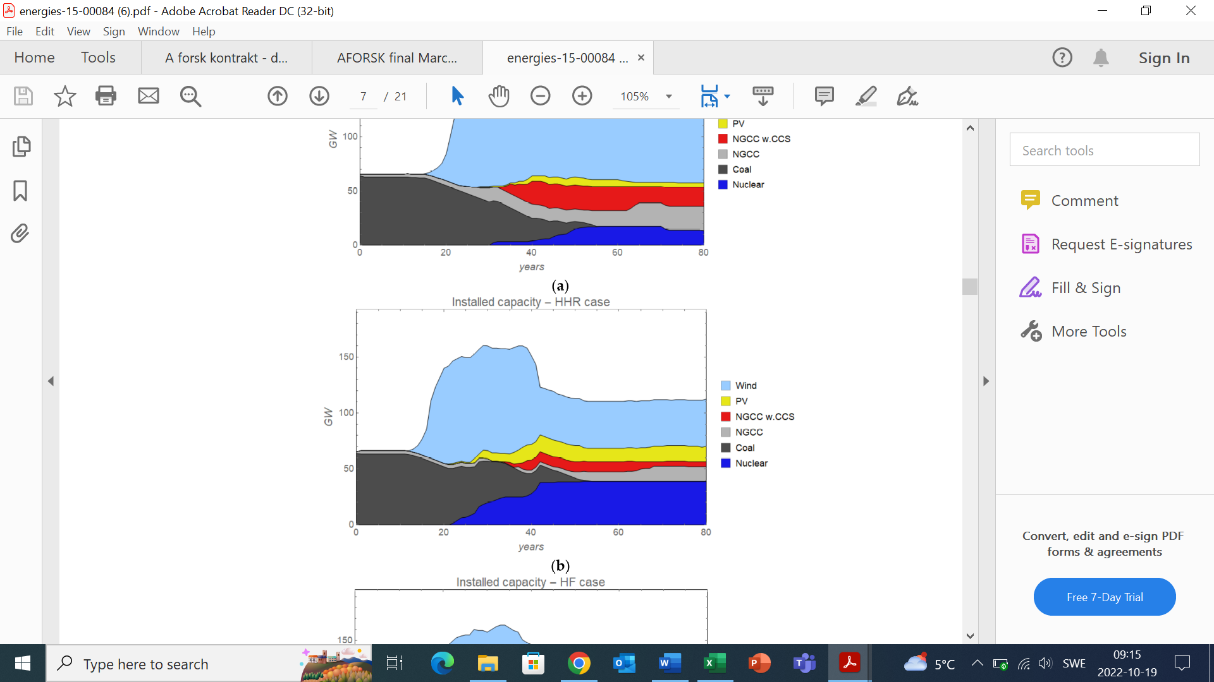
In the figure, we show for the sake of illustrate how the electricity system develops in the model in the case of an increasing carbon tax and where agents are heterogenous in terms of the hurdle rates they use for investment decisions.

- Paper 2: “Investment dynamics in the energy sector under carbon price uncertainty and risk aversion.” Published in Energy and Climate Change..
Investments in the energy sector are carried out under extensive uncertainty. Investments costs are typically very high, a 1 GW nuclear power plant may cost as much as 50 billion SEK or more, and the power plant is expected to remain in place for several decades, which means that we know almost very little with certainty about electricity prices, technology and regulatory change, competition from other actors as well as the impact of geopolitical changes (as the current war against Ukraine shows).
In order to deal with this uncertainty, economists and companies have developed different methods. One approach simply implies that the companies raise the hurdle rate when making net present value calculations, which means that they simply devalue future revenues because they are uncertain.
Another approach is called Value at Risk. It is method that measures the downside risk of an investment. This approach starts from the fact that people/ companies, in general, are more negative about losing money than they are at winning the same amount (the details of which are explained in the paper). This means that they are risk averse.
There is a third approach, which assumes that companies are averse to the variance in the expected returns. This stems from people valuing a loss of say 100 USD higher than a gain of the same amount. There is a mathematical approach to deal with that using utility functions, and that is called mean variance approach (from which modern portfolio theory can be derived) and it goes back to Nobel prize winning economist Harry Markowitz.
In this paper, we let the agents in the model apply these three different risk management approaches. We then compare how both the willingness to invest plays out, as well as how that affects the overall development of the electricity system (installed capacity, electricity prices and CO₂ emissions) over time. This in turn also feeds back into the willingness to invest during subsequent years.
It would go too far to describe the details of our results in a brief report like this, but I nevertheless want to show one graph which illustrates the impact of the electricity price with these three methods both to illustrate the kind of results we can generate but also to illustrate that the level of risk aversion and the method applied may have a significant impact on electricity prices over time.
As seen in the figure, the more risk averse the companies are, regardless of the approach taken, the overall smaller is the production capacity and the higher becomes the electricity price.
These results also provide a theoretical background/explanation to why the previous Swedish government introduced “statliga kreditgarantier” (“state backed credit guarantees”) for investments in green technologies and why the newly elect government has proposed the same for investments in nuclear power.

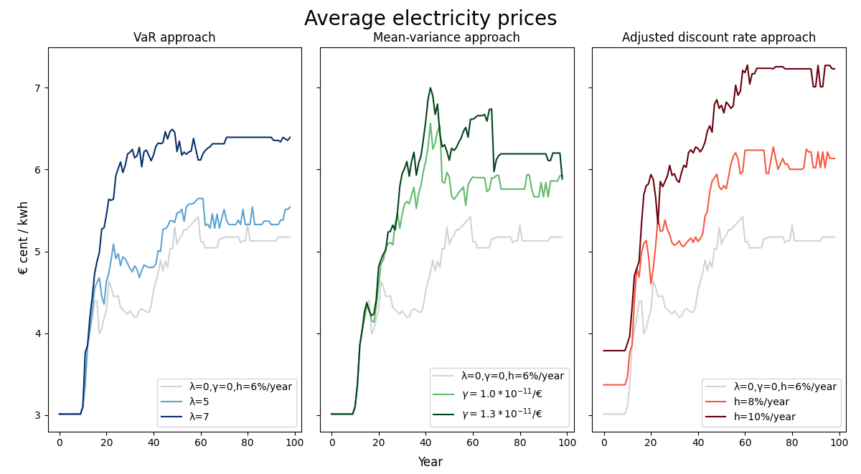
Average electricity price for cases using different risk aversion approaches. All three approaches tend to generate higher electricity prices when a higher level of risk aversion is assumed.

- Paper 3: “Paris Agreement requires substantial, broad, and sustained policy efforts beyond COVID-19 public stimulus packages”, published in Climatic Change.

When the covid crisis struck the world, governments immediately had to act to reduce the spread of the virus but also provide financial support to companies who lost revenues and people who lost their jobs.
These rescue and recovery packages were substantial, and pretty soon a debate emerged on whether this money could be spent in a way to address the economic consequences of covid and climate change at the same time.
A paper in Science received a lot of attention in Sweden and elsewhere. They compared the size of the rescue packages with the estimated cost to make investments in the energy system so that we may reach the Paris climate targets, and found that only a small share of the rescue and recovery packages would be sufficient to deal also with the climate problem. In the paper, published in Science, it was argued that only “a modest fraction of current global stimulus funds can put the world on track to achieve Paris Agreement goals“.
This inspired a lot of discussions in the scientific community, as well as in policy circles. In collaboration with researchers from France we wrote a commentary where we shed additional light on the initial study. We made several points that we think are important to be aware of:
- The corona spending is essentially a one-time effort, while the climate problem requires recurring investments over several decades to come.
- These investments will increase over time as we need to reach deeper emission reductions.
- A policy to deal with the climate problem that relies on government spending and subsidies (as is implicated in the original study) is likely to be much more costly than necessary (since subsidies imply that energy prices fall and people will then likely use more energy).
- For this reason, a carbon tax on the emissions is needed, and the interesting thing is that if a carbon tax is put in place, then we would provide incentives for private actors to invest in green technologies, and there would be no need for governments to provide large subsidies.
- When they estimate the required investments, they do that from models using substantial carbon taxes, which leads to higher energy prices and a lower demand for energy and hence a lower demand for investments in green technologies. But in their study, they do not assume carbon taxes, so their comparison is misleading.
We wrote this paper, not as an argument against their conclusion that governments could in some cases try to reach a win-win situation with the corona spending and climate change. This is a valid point. Our message is that their study created the impression that solving the climate crisis was much easier than it really is (because of the short-term spending versus the long-term needs) and that it seemed to suggest that subsidies was the way forward despite the fact that most economists and policy makers understand that we have to introduce policies that provide incentives against using fossil fuels.

- Paper 4: “Adapting to Uncertainty: Modeling Adaptive Investment Decisions in the Electricity System”, submitted for publication.

We have also submitted a fourth paper where the focus is on how agents may adapt their behaviour if it turns out that their previous decision making was not profitable. For instance, if a company is very risk willing and invests a lot but it turns out that they start to lose money, then they will start to adapt their strategy and become more risk averse.
The key question is then how this adaptive behaviour affects investments, electricity prices, carbon emissions and the overall development of the electricity system (installed capacity).
In this paper, we have also introduced stochastic changes in carbon and fuel prices so that there is additional uncertainty that affects the decision-making process. These are important real term factors that will increase the uncertainty for the agents in the model, e.g., real actors who are about to decide about investments in the electricity sector cannot know what the gas price will be in the future.
In this study, we integrate adaptive decision-making, allowing agents (companies) to annually adjust their hurdle rates, based on the historical financial economic performance of each technology. The model also factors in the diverse risk tolerances among these agents. If a technology doesn't meet the agent’s financial performance expectations (requirement) and their risk tolerance, the hurdle rate for that technology is increased by 0.5 percentage points. Conversely, its associated hurdle rate is decreased by 0.5 percentage points if the economic performance is met.
We examined two distinct scenarios for this study: one where agents are non-adaptive in terms of their hurdle rate values, and another where they exhibit adaptive behaviors with varying degrees of risk tolerance. The results indicate a notable difference in investment choices between non-adaptive and adaptive agents. Specifically, as shown in the figure below, adaptive agents tend to invest more in wind and solar technologies during the initial transition phase (approximately years 30 to 60). However, past this phase, there's a noticeable shift with increased investments in nuclear power, and fewer in wind and solar. This pattern underscores the ability of adaptive agents to modify their investment strategies based on the economic viability of different technologies.
Additionally, the study reveals that adaptive agents with lower risk aversion are more investment-prone, correlating with higher average overall profits and equity values (cumulative profits). However, they also face a higher risk of bankruptcy, highlighting the trade-off between returns and risks.

In conclusion, the insights from this research emphasize the necessity to integrate adaptive behaviors in dynamic electricity system investment models. Such an inclusion would offer a more holistic representation of the dynamic nature of company responses to market shifts, adding a dimension that non-adaptive models might miss.

This figure illustrates the evolution of the installed capacity for each technology in the non-adaptive and the adaptive cases. Each row represents a specific technology. The first column displays the average results derived from 1000 simulation runs. The second and third columns illustrate the range of installed capacity development for the non-adaptive case (second column) and adaptive case (third column). The inner shaded area in black represents the interquartile range (25th to 75th percentiles), while the grey-colored outer range depicts the broader spread between the 10th and 90th percentiles.

Spreading knowledge to the broader society
We have been involved in several activities to spread the knowledge from our work to various actors in society, including government committees and media. For instance, Azar has been involved in:
- the government committee: ”regeringens samverkansgrupp för näringslivets klimatomställning” (-2022)
- the “Statlig Offentliga Utredningen”: Sveriges Globala Klimatavtryck, as well as
- a reference group to Fossilfritt Sverige.
In the group “regeringens samverkansgrupp för näringslivets klimatomställning” lead by the Näringsdepartementet under the previous government, we had extensive discussions about the role of companies and the state in order to enable investments in green technologies.
We have also published seven articles in Swedish media, for instance one on how carbon taxes may help to solve the climate crisis (by providing incentives to invest in green technologies, Azar 2021), and one on the pros and cons with national targets for consumption-based emissions (Azar 2022). In addition, we have published two articles, one in Aftonbladet (Azar 2023a) and one in the newsmagazine Focus on the Sweden’s carbon emissions in relation to other countries (Azar 2023b). Two articles have been published in Dagens Nyheter about the transition of the energy systems and how Sweden (and some European countries) have performed so far (Azar 2023c,d and a third is on its way). We have also published a popular science article about how the sun functions (the internal processes in the sun that leads to energy being radiated to the Earth, see Azar 2023e).

SCIENTIFIC PUBLICATIONS (AND SUBMITTED PAPERS) FROM THE PROJECT:
- Yang, J., Azar, C., Lindgren, K., 2021. Modelling the Transition towards a Carbon-Neutral Electricity System—Investment Decisions and Heterogeneity. Energies 15(1), 84; https://doi.org/10.3390/en15010084.
- Tanaka, Katsumasa, Christian Azar, Olivier Boucher, Philippe Ciais, Yann Gaucher & Daniel J. A. Johansson, 2022. Paris Agreement requires substantial, broad, and sustained policy efforts beyond COVID-19 public stimulus packages. Climatic Change 172. https://link.springer.com/article/10.1007/s10584-022-03355-6
- Yang, J., Fuss, S., Johansson, D.J.A., Azar, C., 2023. Investment Dynamics in the Energy Sector under Carbon Price Uncertainty and Risk Aversion. Energy and Climate Change 4, 100110. https://doi.org/10.1016/j.egycc.2023.100110
- Yang, Jinxi, Daniel J.A. Johansson, Christian Azar. Adapting to Uncertainty: Modeling Investment Strategies in the Electricity System. Submitted for publication.

PhD Thesis
Yang, J., 2023. Exploring the Transition to a Low-Carbon Electricity System using Agent-Based Modelling. Chalmers University of Technology. Available here: https://research.chalmers.se/en/publication/537688

Publications in the popular press
Azar, C., 2021. Koldioxidskatt bästa sätt att lösa klimatproblemet. GP 6/11. https://www.gp.se/kultur/kultur/h%C3%B6j-skatten-p%C3%A5-koldioxid-b%C3%A4sta-s%C3%A4ttet-r%C3%A4dda-klimatet-1.58594803
Azar, C, 2022. Klimatribban höjs – men till vilket pris? Tidskriften Fokus 19/4 https://www.fokus.se/vetenskap/klimatribban-hojs-men-till-vilket-pris/
Azar, C., 2023a. Finland ligger inte före Sverige. Aftonbladet 9/3. https://www.aftonbladet.se/debatt/a/3EV5We/christian-azar-finland-ligger-inte-fore-sverige-i-omstallningen
Azar, C., 2023b. Sveriges utsläpp av växthusgaser i ett globalt perspektiv. (Bättre än vad vi vill tro). Fokus 1/6, s. 34-37. https://www.fokus.se/opinion/inte-sadana-utslappsbovar-som-vi-tror/
Azar, C., 2023c. Det är inte utflyttning av industrier som drivit ned utsläppen i Sverige. Dagens Nyheter 25/9. https://www.dn.se/kultur/christian-azar-det-ar-inte-utflyttning-av-industrier-som-som-drivit-ned-utslappen-i-sverige/
Azar, C., 2023d. Utsläppen av koldioxid har faktiskt minskat kraftigt i Sverige. DN Kultur, 21/8. https://www.dn.se/kultur/christian-azar-utslappen-av-koldioxid-har-faktiskt-minskat-kraftigt-i-sverige-men-det-racker-inte/
Azar, C., 2023e. Kärnkraften i solen. Tidskriften FOKUS 17/2. https://www.fokus.se/vetenskap/karnkraften-i-solen/

See here: https://www.oecd-nea.org/upload/docs/application/pdf/2020-12/egc-2020_2020-12-09_18-26-46_781.pdf; https://energy.mit.edu/news/building-nuclear-power-plants/ and here: https://apnews.com/article/business-environment-united-states-georgia-atlanta-7555f8d73c46f0e5513c15d391409aa3.
https://www.riksgalden.se/sv/var-verksamhet/garantier-och-lan/grona-kreditgarantier/; https://www.riksdagen.se/sv/dokument-lagar/dokument/svensk-forfattningssamling/forordning-2021524-om-statliga-kreditgarantier_sfs-2021-524
https://www.svd.se/a/rEa5Wm/m-satsar-400-miljarder-for-ny-karnkraft; https://www.regeringen.se/tal/2022/10/regeringsforklaringen/
https://www.science.org/doi/10.1126/science.abc9697
See for instance the news article in Dagens Nyheter: https://www.dn.se/vetenskap/pandemin-visar-att-varlden-har-rad-med-parisavtalet/
https://www.regeringen.se/rattsliga-dokument/statens-offentliga-utredningar/2022/04/sou-202215/

